**Landing, Login, and Enrollment Pages Development**

Nicholi D’Amato

The University of Arizona Global Campus

CST 499: Capstone for Computer Software Technology

Instructor: Joseph Rangitsch

April 24, 2024

Creating a website that allows for interactions with a database, such as a student portal page that students can use to register for classes has a fair number of steps. We also need to run a database for data to be entered, creating webpages with code such as PHP to interact with that database. And ensuring that everything works correctly with a minimum number of bugs and good workflows. We will showcase some of those steps below, as well as what you might expect the code itself to look like.

## Explain how to run a PHP file in XAMPP.

Running a PHP file in XAMPP can be simple if your environment is setup correctly, if not, there may be some troubleshooting!

1. First, download and install XAMPP from [here.](https://sourceforge.net/projects/xampp/)
   1. Default settings are fine.
2. Once installed, launch the XAMPP Control Panel **as an administrator.**
3. If you have previously installed Apache or MySQL, or if you have anything running on the default ports, you can change the ports these services run on in the Configuration -> Service and Port Settings.
   1. If you change these ports, you must then go to the “Config” button on the line for that service, select the hddpd.conf and change any instances of the original port, to the new one. For example, changing Apache to run from port 80 to 85
4. Now, place your PHP file in the directory you installed XAMPP in, preferably in a new folder for that website.
5. Navigate to the port in your browser, such as http://localhost:85/CST%20310%20Site/index.php

## Create the landing page, login page, and registration page for new users.

Figure 1: Index

Figure 2: Login

Figure 3: Registration

## Create the MySQL database and tables.

## Discuss the MySQL database functions that you used and the steps you took to create the database connection custom class.

To create the database with the users table:

* I created the database cst310website
* I used the UI to add a users table
* I added all the fields that were required, and designated the id and email fields as primary keys, with the other fields not-null to ensure they are filled in on insert.

For my custom connection class I have:

## Develop the registration page layout.

## Develop the registration page PHP source code.

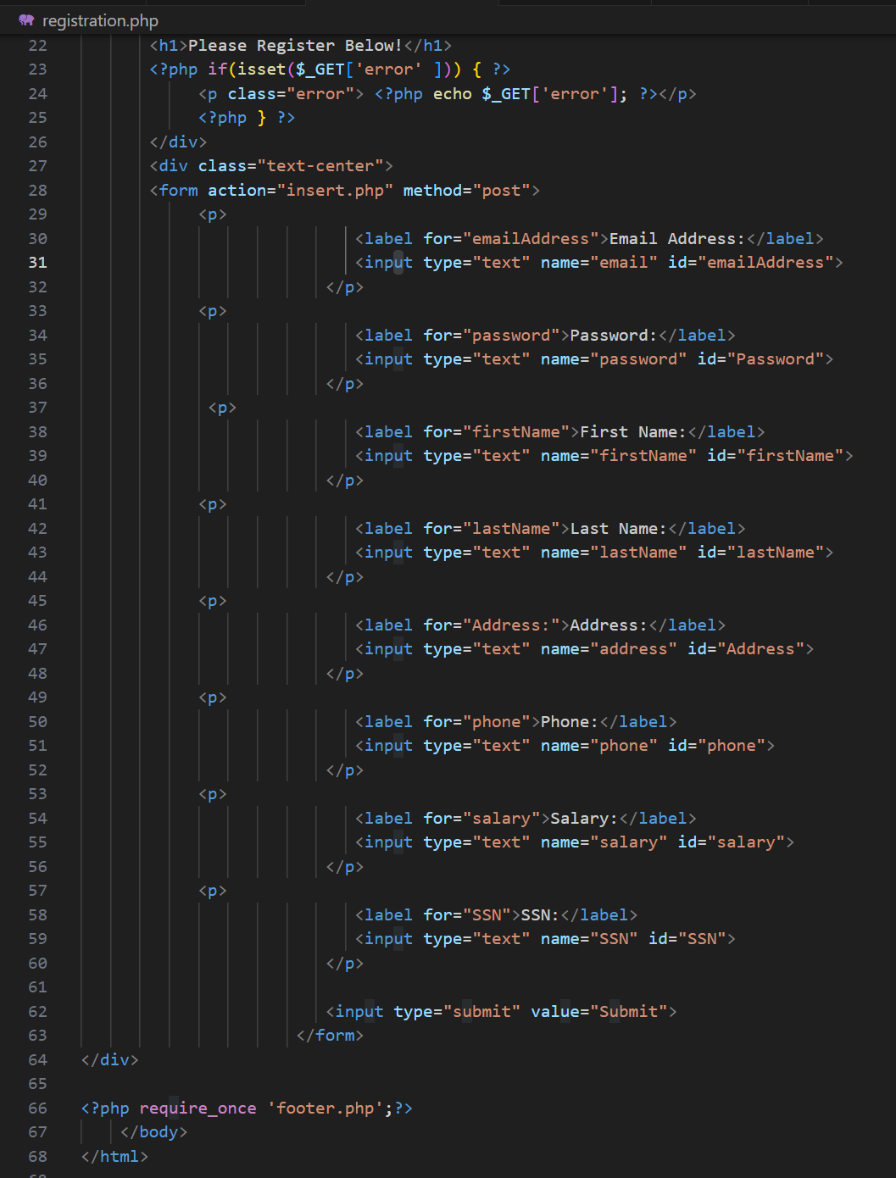

## Develop the table that saves the user information in the database.

Figure 4: Table After Insert

## Explain the steps taken to create the registration page and save the user information in the database.

The first step was to create a form on the registration page that will pass information into the insert code running on the insert.php page. The form has a label and an input for each of the fields that we are gathering, as well as a submit button.

On hitting the submit button, we post the inputs to the insert.php page. The insert then connects to the database, gathers the values we are going to insert into variables, then inserts those variables into the database. Template used can be found on the GeeksForGeeks *How to Insert Form Data into Database using PHP ? page.*

## Provide screenshots of all developed pages, database, tables, layout, and source code.

Figure 5: Students Table



Figure 6: Classes Table



Figure 7: Registrations Table



Figure 8: Waitlist Table

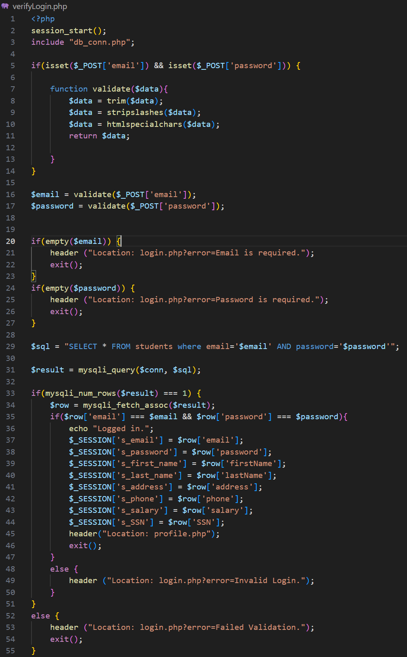 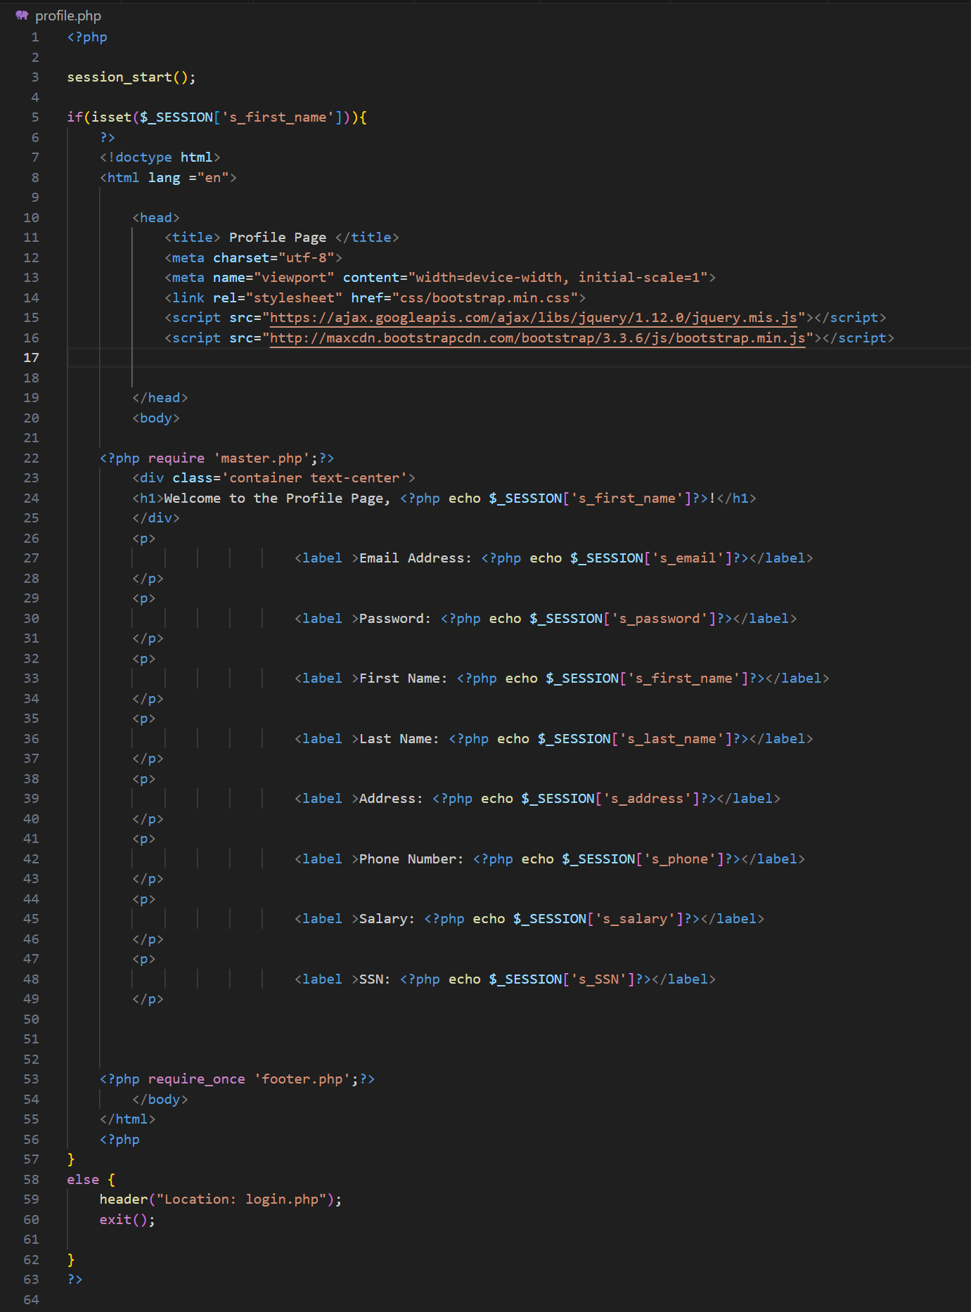

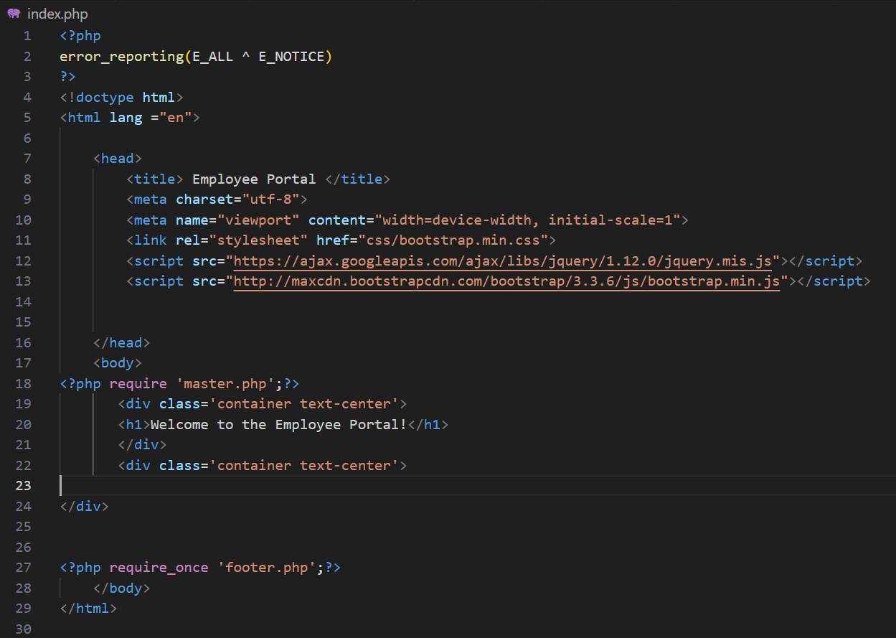 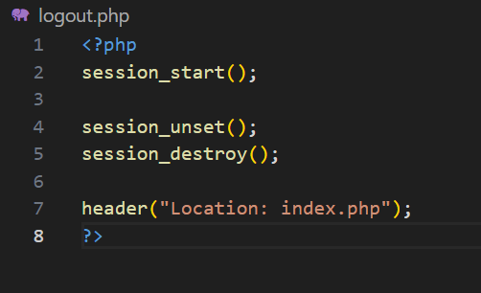

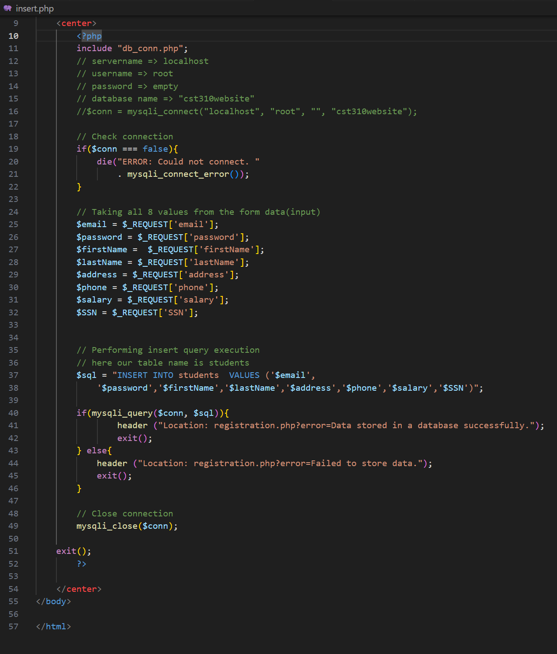

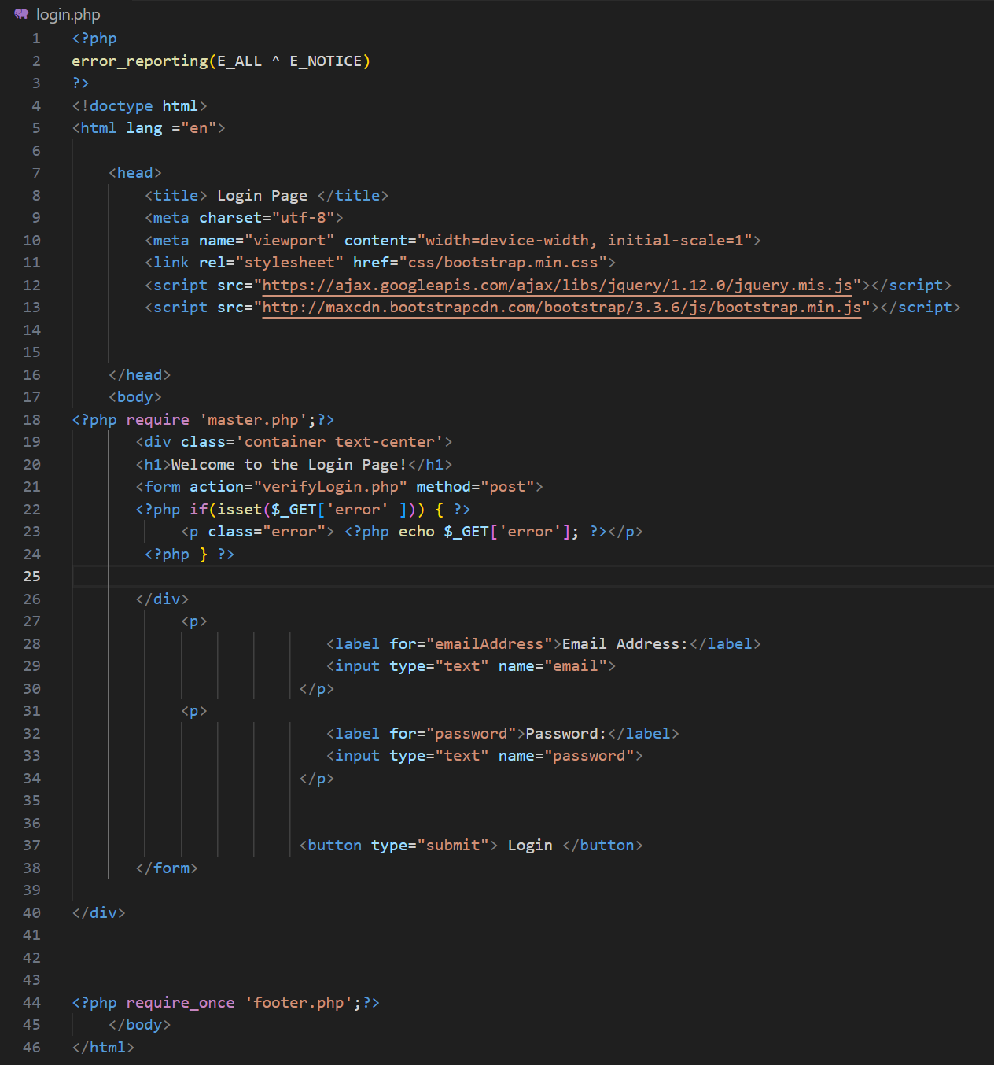

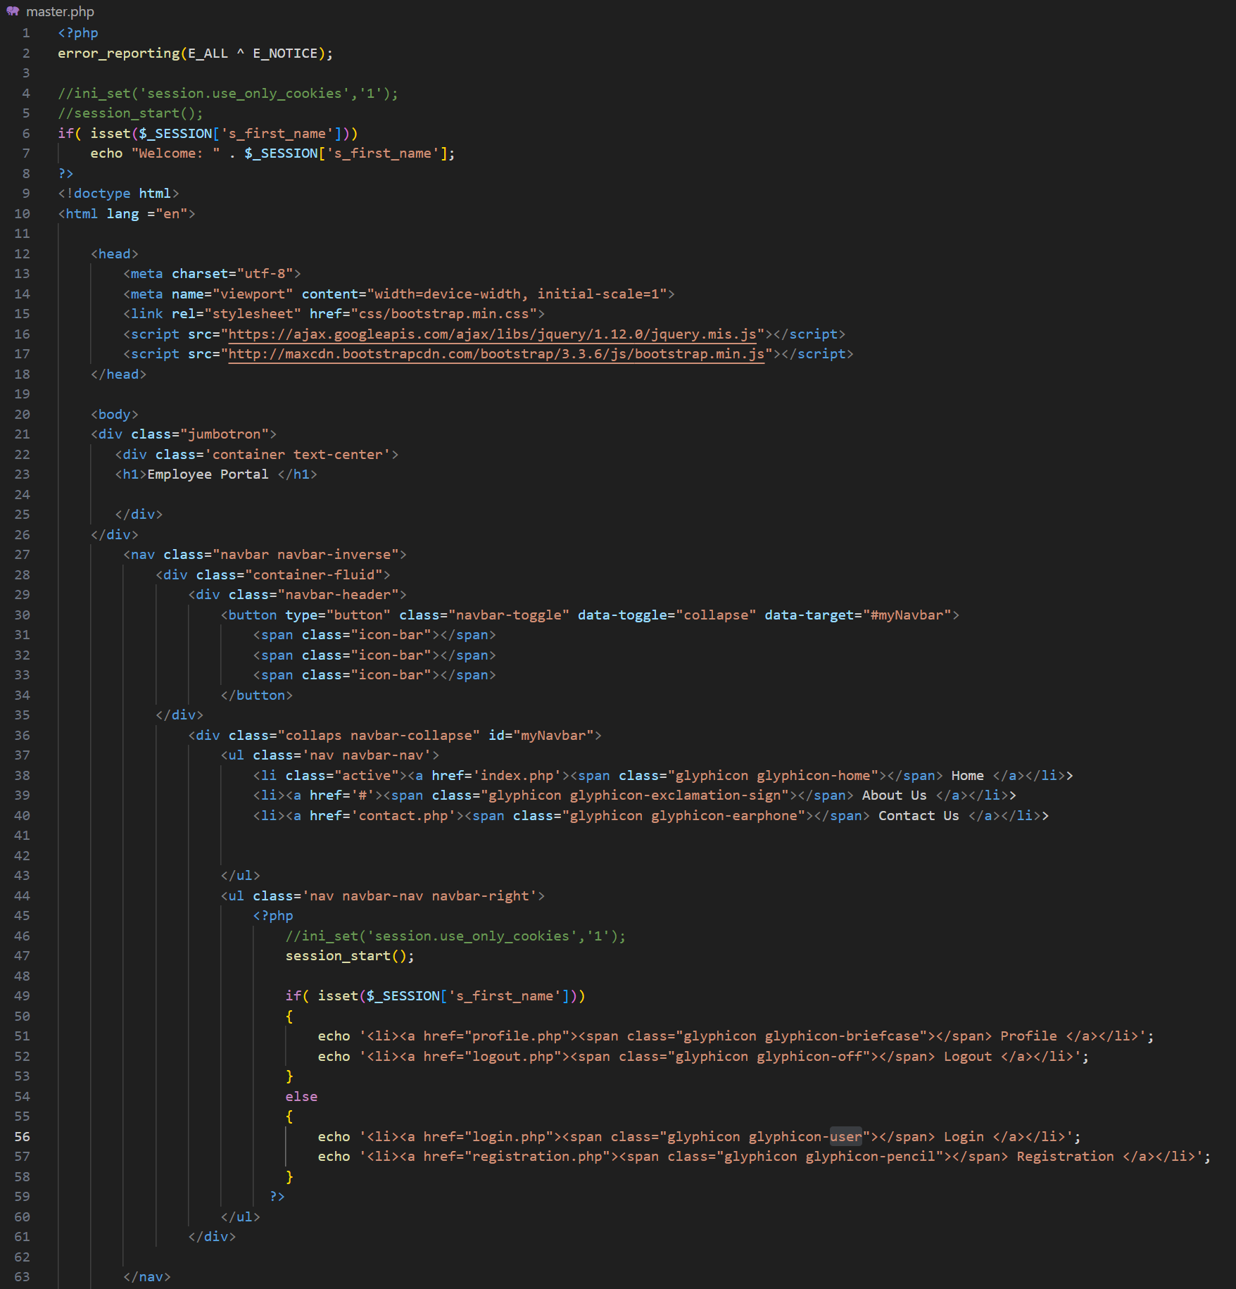

All the steps above are just the start of the work we are doing on this project and cover only the bare bones. We still need to create the classes, the class schedule, the pages to view those classes, and the methods and logic to register and withdraw from classes. Working through these issues will be a fun challenge and be quite educational!

References:

*How to Insert Form Data into Database using PHP ?* (n,d,). GeeksForGeeks. Retrieved December 14, 2023 from [https://www.geeksforgeeks.org/how-to-insert-form-data-into- database-using-php/](https://www.geeksforgeeks.org/how-to-insert-form-data-into-%09database-using-php/)